Help her to find her Pot of Gold at the end of the Rainbow!  Recipients (Rainbow Girls) may be of any age or years in Rainbow.  She should generally be accepted as a girl who best represents the tenets of Rainbow, as exemplified by the seven virtues, especially service.  Nominations should be articulate to aid in the selection of the recipient.  Multiple nominations can be made from any Assembly in New Hampshire.  For more information, contact  - Dad Peter Masterson jpmasterson@comcast.net  - Dad Brian Smith brijsmith@aol.com | International Order of the Rainbow for Girls in New Hampshire  c/o Peter Masterson, Dad Advisor | Peter Masterson  273 Portsmouth Ave  Stratham, NH 03885 | 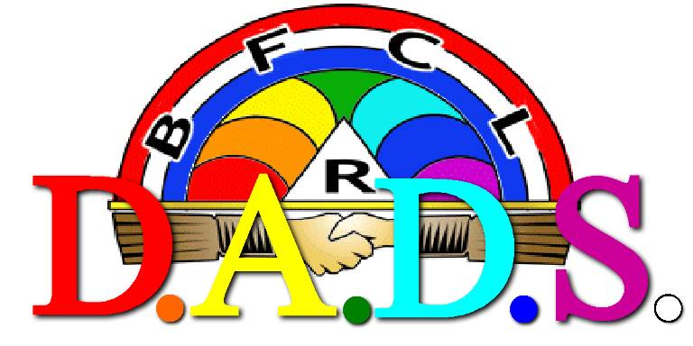  - Dad Advisors, Dedicated Service

  Her Pot of Gold is at the end of the Rainbow!  The Beginning…  In 2014, the Dad Advisors of New Hampshire decided that they wanted a venue to recognize the young women of the Order who were exemplifying the Rainbow lessons, especially Service, in their daily lives.  They created the D.A.D.S Award (Dad Advisors, Dedicated Service) for that service recognition, an honorarium that is a cash stipend given to one girl in New Hampshire each year, which can be used for any purpose decided upon by the recipient.  Originally formed by a group of Past State Dad Advisors, the D.A.D.S Association has since expanded their membership to include any Rainbow adult. | “The D.A.D.S Club has enabled our young women to be more, do more, and serve more.”  - Tracey Thompson  We currently have several men and women who pay dues yearly to this prestigious club membership, and these dues, as well as various fundraisers, help to provide for the DADS Honorarium.  Service Driven  The first D.A.D.S Award was given to Miss Jordyn Hotchkiss of Weare, NH, in 2014, who used the fund to build homes with Habitat for Humanity.  Since 2014, we have been able to award over $6000 to girls who have exemplified the Rainbow lessons throughout their daily lives at church, school, and other extracurricular activities.  Subsequent recipients have used the award for training, mission trips, schooling and other service causes. | Eligibility  To qualify, you must be a Rainbow girl who is:  - An active member  - Any age  - Recommended by a Rainbow adult  The D.A.D.S. Award is presented at our annual Grand Assembly in July.  A Rainbow adult must submit a letter to the D.A.D.S. Club explaining how the girl represents the principles of the lessons of Rainbow, especially Service, with specific examples included.  This letter is due May 15 and can be given to Dad Peter Masterson, Chairman of the D.A.D.S Club.  Contact Us  International Order of the Rainbow for Girls in New Hampshire  c/o Peter Masterson, Dad Advisor  273 Portsmouth Ave  Statham, NH 03885  jpmasterson@comcast.net  www.nhrainbow.org

